Information on tourist spots around Ojiya

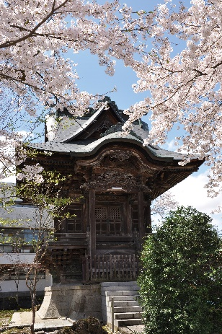

Akashi-dō and Oman-ga-ike

- Akashidō (cultural property designated by Ojiya-city)

Akashidō is a small hall that honors Horijiro Masatoshi who is the founder of Ojiya Chijimi made improvements to linen fabric that was traditionally woven in this area by weaving weft twisting tightly which makes crimped surface, the feature of Ojiya Chijimi. About a hundred and 30 years from his death, in 1845-1854, those who concerned with Ojiya Chijimi created Akashidō with Japanese zelkova and beautiful wood carving inside and out.
Located on left back of the hall, there is tomb of him and his wife, and every year people in Ojiya Chijimi business hold Buddhist memorial service for him on September 12th.

- Oman-ga-ike (cultural property designated by Ojiya-city)

Oman-ga-ike is a pond that Masatoshi’s wife Man used to bleach cloth in. A spring was used to gush out from the bottom of the pond. It became very small, however, it has been remaining for hundreds of years because local people carefully preserved it for generations with great respect and gratitude for Hori family.

Episodes
- Horijiro Masatoshi had two daughters named Chiyo and Kesa. The two girls were proficient in weaving Chijimi and also, Chiyo was a good dancer and Kesa was a good singer. Their skills have been handed down and still practiced as “Ochiyo odori”(Chiyo dance) and folk song “Okesa” in many areas.
- Local people used to practice “Kagura”, the sacred dance and music, at Oman-ga-ike.

